**DATABASE SYSTEMS LAB – PROJECT SYNOPSIS**

**HOSPITAL MANAGEMENT SYSTEM**

|  |
| --- |
| NAME : N.SAIANIRUD REDDY |

**OBJECTIVE:**

The project **Hospital Management System** includes registration of patients, storing their details into the system, and also computerized billing in the pharmacy and labs. The system has the facility to give a unique id for every patient and stores the details of every patient and the staff automatically. It includes a search facility to know the current status of each room. The system contains a database where all the information will be stored safely. The system will user-friendly and error free.

**PROJECT DESCRIPTION:**

The Hospital Management System can be entered using a username and password. It is accessible either by an administrator or receptionist. Only they can modify the database. The data can be retrieved easily. The interface is very user-friendly. The data are well protected and makes the data processing very fast. The purpose of the project is to computerize the Front Office Management of Hospital. It deals with the collection of patient’s information, diagnosis details, etc.

Earlier it was done manually. The main function of the system is to register and store patient details and doctor details and retrieve these as and when required.

**ADVANTAGES:**

* It is fast, efficient and reliable
* Avoids data redundancy and inconsistency
* User-friendly
* Easy accessibility of data
* Provides more security and integrity of data

**REQUIRED SOFTWARE:**

Front end: Java Back end: SQL

**ER Diagram:**

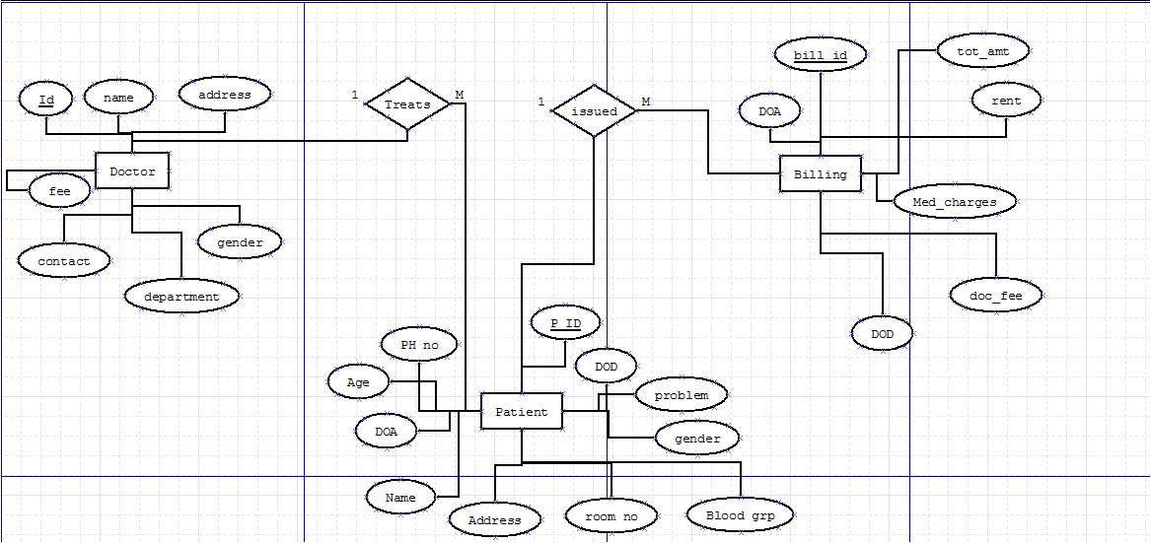

**Tables:**

|  |  |  |
| --- | --- | --- |
| Doctor | Patient | Billing |
| create table Doctor  (  no varchar(20),  name varchar(20),  address varchar(100),  contact varchar(20),  dept varchar(50),  gender varchar(20),  fee varchar(20),  primary key(no)  ); | create table Patient(  p_id varchar(20),  name varchar(20),  room_no varchar(20),  address varchar(20),  bloodgrp varchar(20),  gender varchar(20),  doa varchar(20),  ph_no varchar(20),  age varchar(20),  cur_pblm varchar(20),  d_id varchar(20),  dod varchar(20),  primary key(p_id),  foreign key(d_id) references Doctor(no) on delete cascade  ); | create table Billing(  bill_id varchar(20),  p_id varchar(20),  rent varchar(20),  amt varchar(20),  doa varchar(20),  dod varchar(20),  docfee varchar(20),  med_chrgs varchar(20),  primary key(bill_id),  foreign key(p_id) references Patient(p_id) on delete cascade  ); |

|  |  |  |  |  |  |  |
| --- | --- | --- | --- | --- | --- | --- |
| ID | name | address | Ph no | dept | gen | fee |
| 1 | ram | KMC | 8333003736 | dermatology | male | 200 |
| 2 | sam | KMC | 4556768 | cardiology | male | 350 |
| 3 | sita | KMC | 98689 | opd | female | 200 |
| 4 | anil | KMC | 47779079 | Neurology | male | 300 |

**Doctor Table:**

**Billing Table:**

|  |  |  |  |  |  |  |  |
| --- | --- | --- | --- | --- | --- | --- | --- |
| Bill id | P ID | RENT | AMOUNT | DOA | DOD | FEE | CHARGES |
| 1234 | 22 | 500 | 9000 | 23/4 | 25/5 | 200 | 500 |
| 1254 | 56 | 700 | 8888 | 6/3 | 23/3 | 200 | 700 |
| 2344 | 67 | 600 | 5595 | 5/7 | 7/9 | 200 | 300 |
| 6788 | 57 | 800 | 3455 | 4/10 | 7/11 | 200 | 200 |

**Patient Table:**

|  |  |  |  |  |  |  |  |  |  |  |  |
| --- | --- | --- | --- | --- | --- | --- | --- | --- | --- | --- | --- |
| ID | NAME | ROOM NO | ADDRESS | BLOOD GP | GENDER | DOA | PH NO | AGE | PROBLEM | D ID | DOD |
| 1 | RITA | 21 | MIT | O+ | FEMALE | 23/5 | 98898099800 | 18 | SKINDISEASE | 123 | 5/6 |
| 2 | SAMEER | 34 | MIT | B+ | MALE | 25/10 | 789097980909 | 25 | KIDNEY | 234 | 30/12 |
| 3 | RAJ | 24 | MIT | AB- | MALE | 31/2 | 789898989989 | 30 | HEART | 435 | 9/4 |

Doctor Billing

|  |
| --- |
| ID |
| Name |
| Address |
| Contact |
| Dept |
| Gender |
| Fee |

|  |
| --- |
| PID |
| Name |
| Room no |
| Address |
| Blood grp |
| Gender |
| DOA |
| Ph.No |
| Age |
| Problem |
| DID |
| DOD |

|  |
| --- |
| Bill ID |
| PID |
| Rent |
| Amount |
| DOA |
| DOD |
| Doc Fee |
| Med charges |

Patient

**Screenshots:**

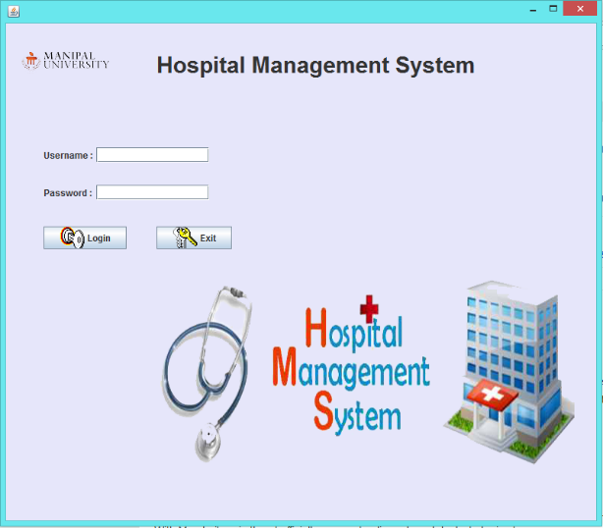 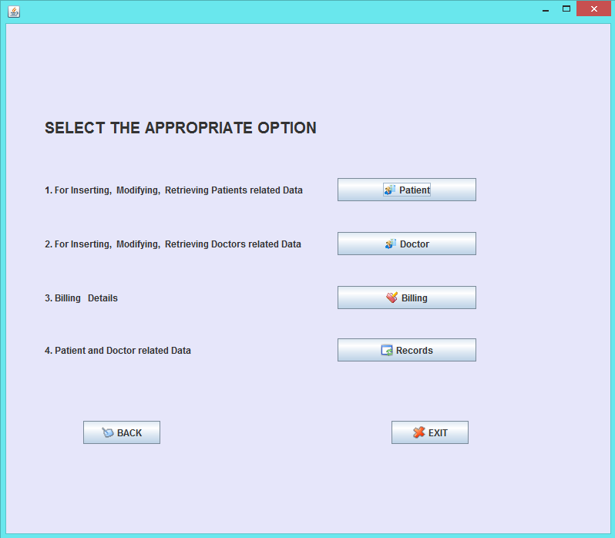

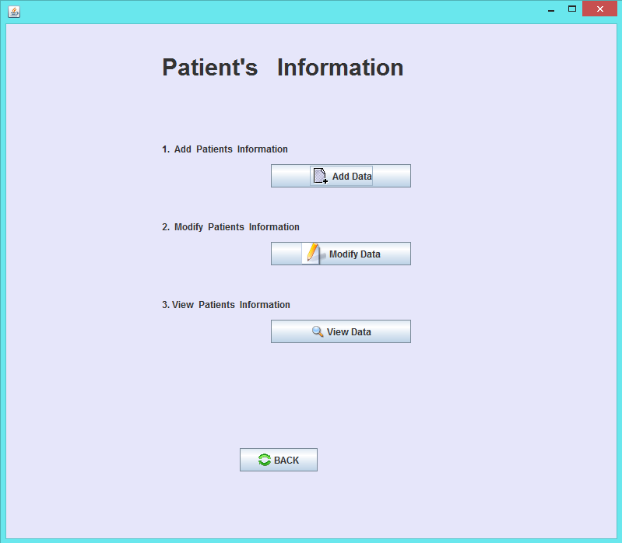 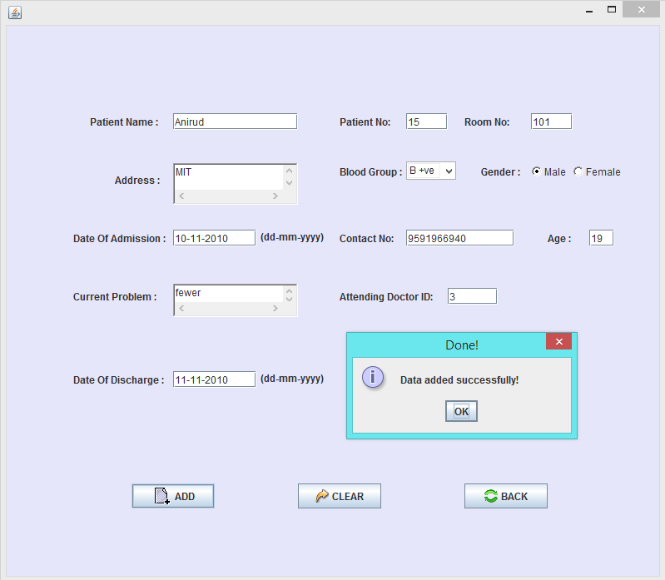

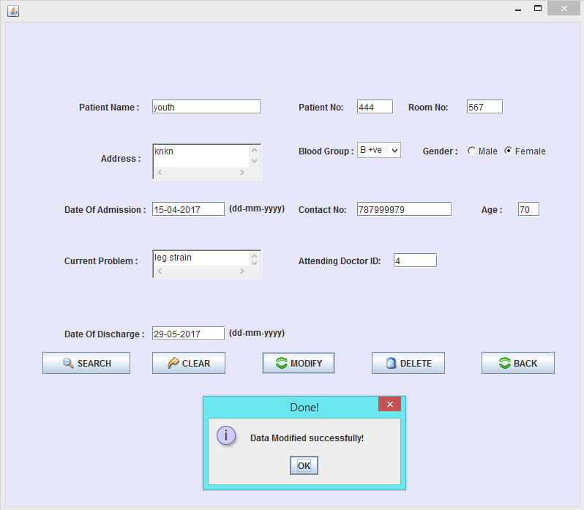 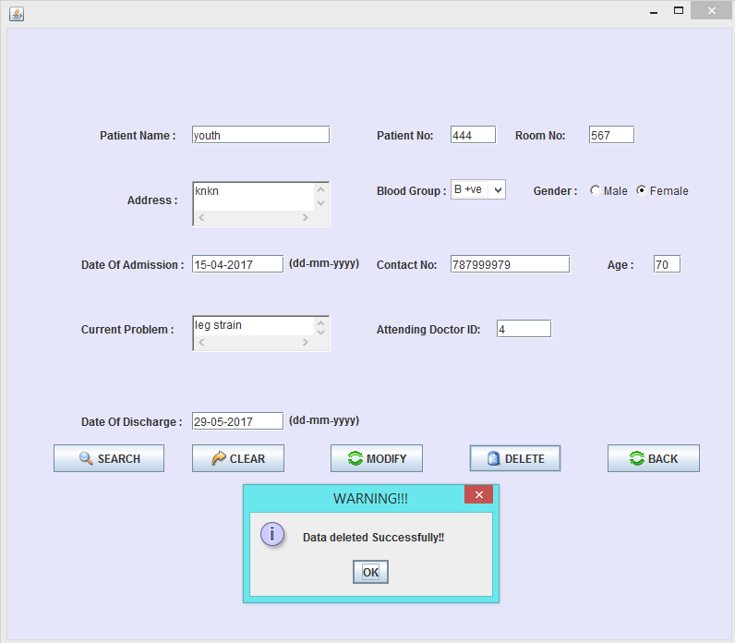

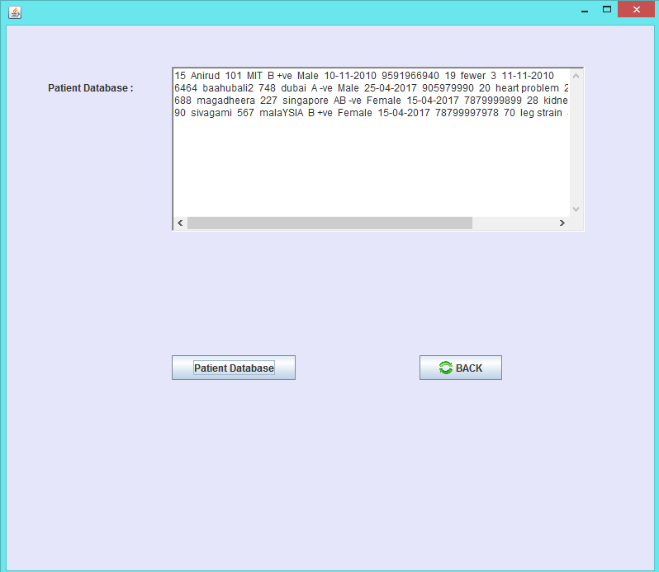 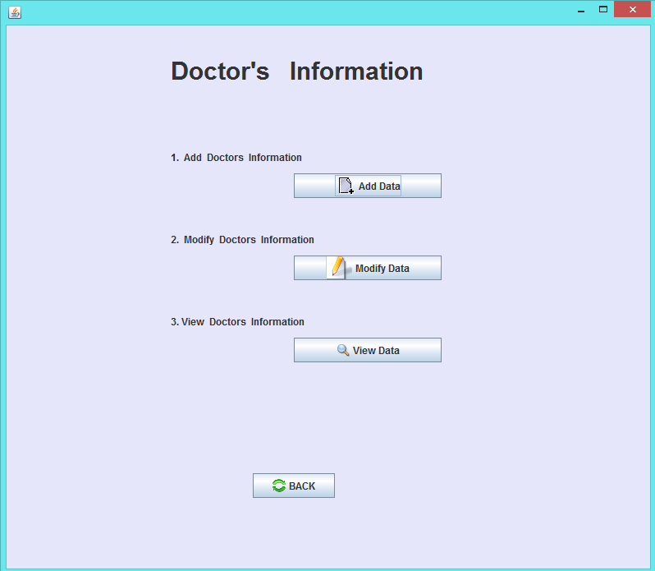

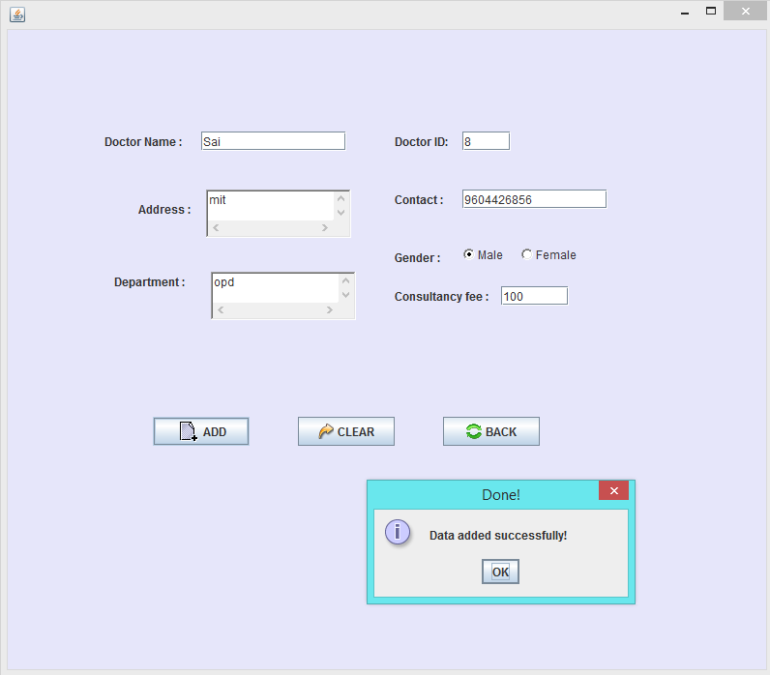 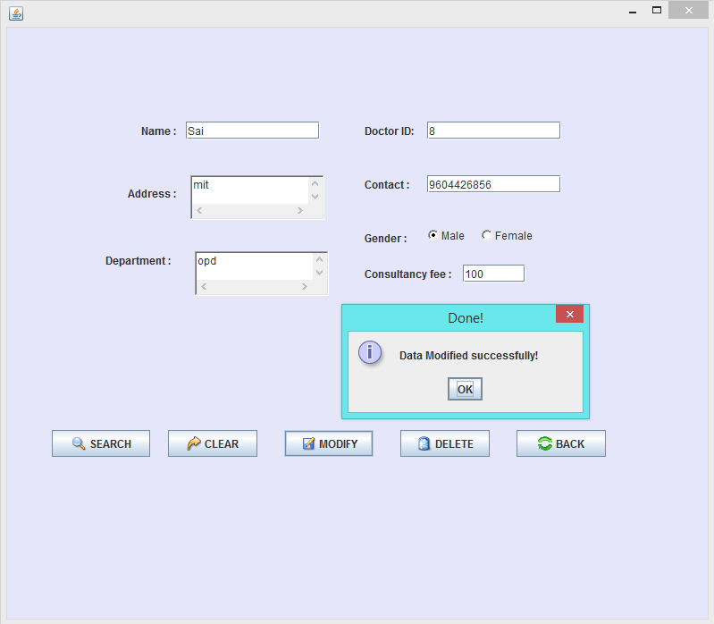

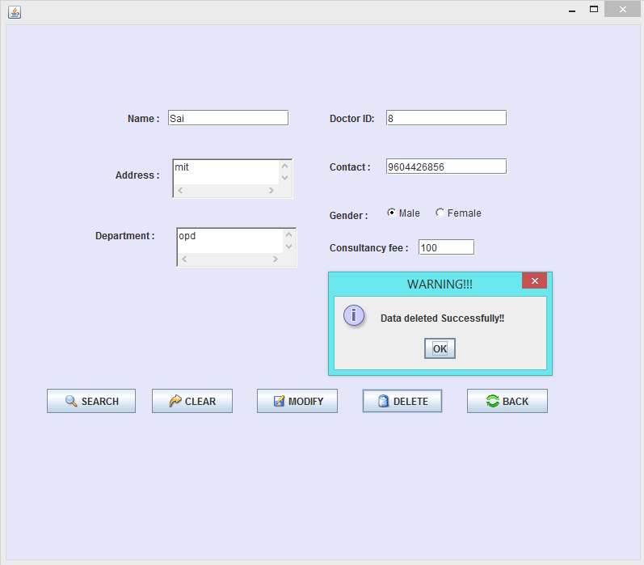 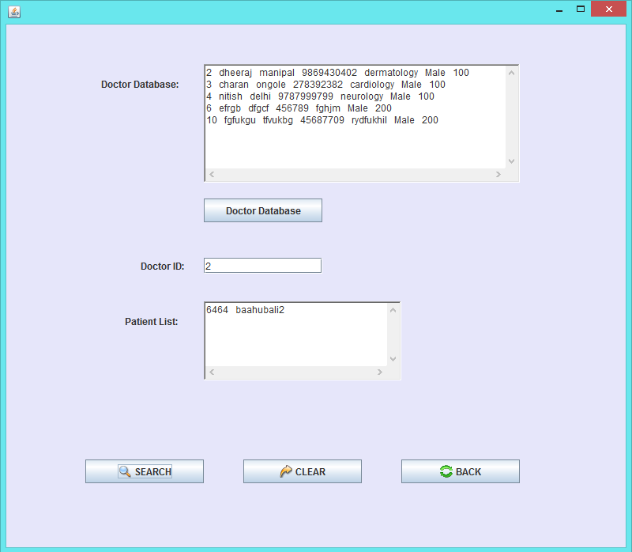

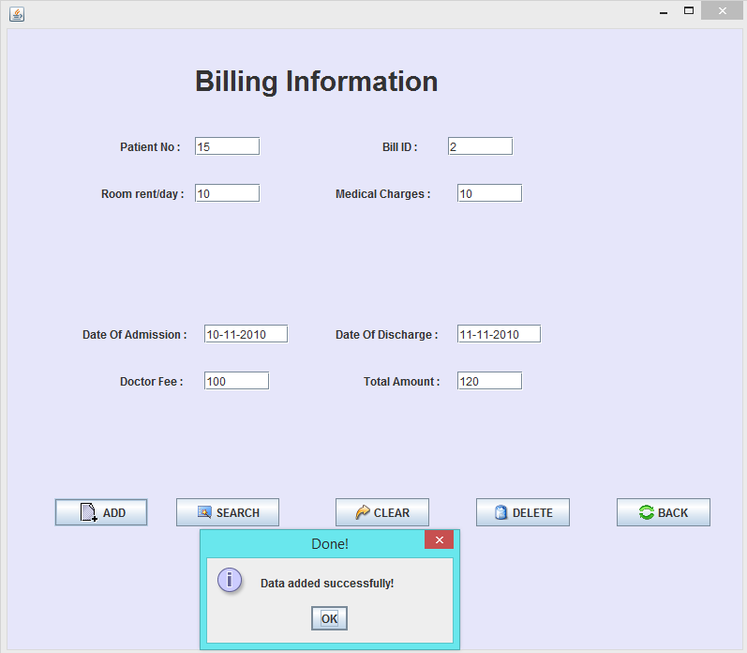 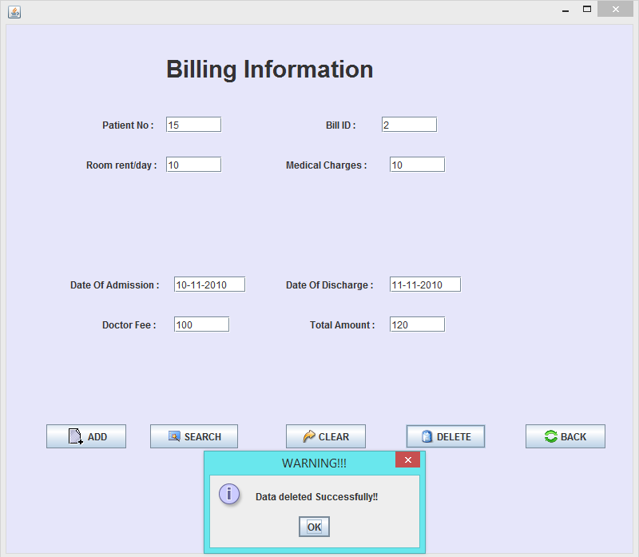

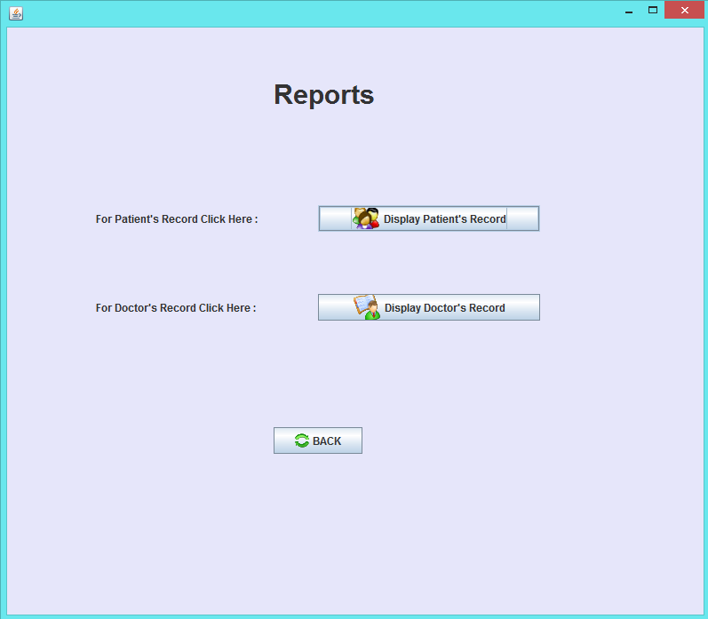 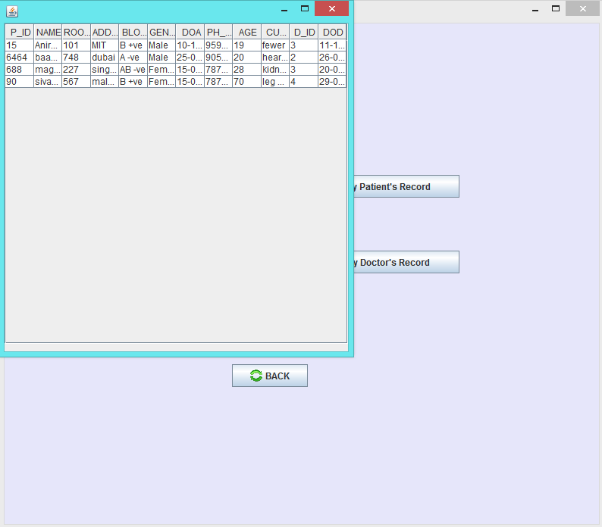

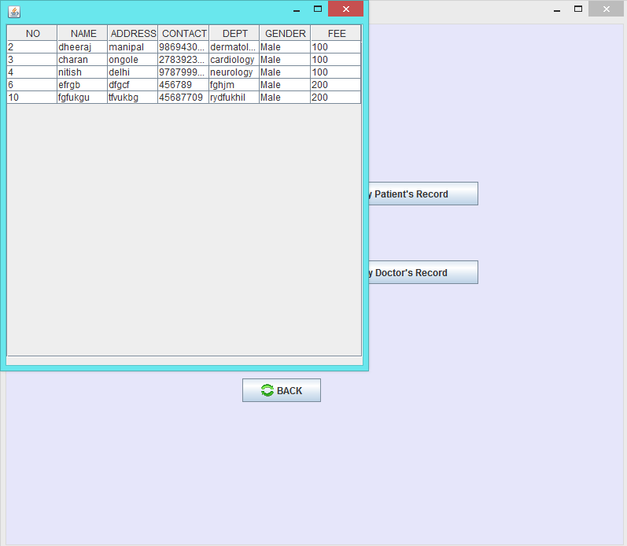 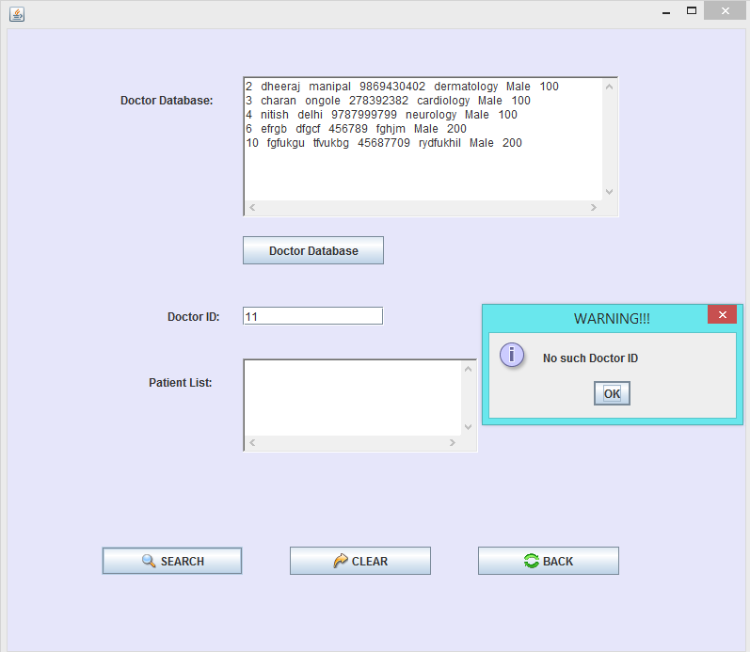

**Abstract:**

* Hospital management system is used to maintain list of patients, doctors and their billing details
* User can login using user Id and password.
* Patient details includes person name, id, room no, blood group etc.
* Doctor details includes name, department, id, contact, gender etc.
* Billing details includes net total, date of admit and date of discharge etc.
* Records displays all the above database.
* Admin can create new patient details.
* Admin can modify or delete patient/doctor/billing records.

|  |  |
| --- | --- |
| **File Name : dbmsmain.java** |  |
| import java.awt.*;  import java.awt.event.*;  import javax.swing.*;  public class dbmsmain extends JFrame  {  JLabel lmain,lhm,lhead,username,password;  JTextField tuser;  JPasswordField tpass;  JButton login,exit;  public dbmsmain()  {  JFrame jframe=new JFrame();  jframe.getContentPane().setBackground  (new Color(230,230,250));  jframe.setDefaultCloseOperation  (JFrame.EXIT_ON_CLOSE);  jframe.setSize(800,700);  jframe.setVisible(true);  jframe.setLayout(null);  lmain=  new JLabel(new ImageIcon("images/mulogo.png"));  jframe.add(lmain);  lmain.setBounds(5,30,150,50);  lhm=new JLabel(new ImageIcon("images/hm.png"));  lhm.setBounds(180,300,600,300);  jframe.add(lhm);  lhead=new JLabel("Hospital Management System");  jframe.add(lhead);  lhead.setBounds(200,30,600,50);  lhead.setFont(new Font("Arial",Font.BOLD,30));  username=new JLabel("Username :");  username.setBounds(50,150,70,50);  jframe.add(username);  tuser=new JTextField(30);  tuser.setBounds(120,165,150,20);  jframe.add(tuser);  password=new JLabel("Password :");  password.setBounds(50,200,70,50); | jframe.add(password);  tpass=new JPasswordField(30);  tpass.setBounds(120,215,150,20);  jframe.add(tpass);  login=new JButton("Login",new ImageIcon("images/key.gif"));  login.setBounds(50,270,110,30);  jframe.add(login);  exit=new JButton("Exit",new ImageIcon("images/exits.png"));  exit.setBounds(200,270,100,30);  jframe.add(exit);  login.addActionListener(new ActionListener()  {  public void actionPerformed(ActionEvent ae)  {  String loginname,loginpass;  loginname=tuser.getText();  loginpass=tpass.getText();  if(loginname.equals("system") && loginpass.equals("system"))  {  new start();  setVisible(false);  }  else{  JOptionPane.showMessageDialog  (null,"Invaild Username or Password" , "WARNING!!!",JOptionPane.  INFORMATION_MESSAGE);  tuser.setText(""); tpass.setText("");}  }});  exit.addActionListener(new ActionListener()  {  public void actionPerformed(ActionEvent ae)  { System.exit(0); }  });}  public static void main(String[] args)  {  new dbmsmain();  }} |
| **File Name : start.java**  import java.awt.*;  import java.awt.event.*;  import javax.swing.*;  import java.util.*;  class start extends JFrame implements ActionListener {  JButton bpat,bdoc,bbill,breport,bback,bexit;  JLabel linfo,linfo1,linfo2,linfo3,linfo4;  start() {  JFrame jframe=new JFrame();  jframe.getContentPane().setBackground(new Color(230,230,250));  jframe.setDefaultCloseOperation  (JFrame.EXIT_ON_CLOSE);  jframe.setSize(800,700);  jframe.setVisible(true);  jframe.setLayout(null);  linfo=new JLabel  ("SELECT THE APPROPRIATE OPTION");  linfo.setBounds(50,120,500,30);  jframe.add(linfo);  linfo.setFont(new Font("Arial",Font.BOLD,20));  linfo1=new JLabel  ("1. For Inserting, Modifying, Retrieving Patients related Data");  linfo1.setBounds(50,275,335,20);  jframe.add(linfo1);  linfo2=new JLabel  ("2. For Inserting, Modifying, Retrieving Doctors related Data");  linfo2.setBounds(50,205,335,20);  jframe.add(linfo2);  linfo3=new JLabel("3. Billing Details");  linfo3.setBounds(50,345,150,20);  jframe.add(linfo3);  linfo4=new JLabel  ("4. Patient and Doctor related Data");  linfo4.setBounds(50,413,250,20);  jframe.add(linfo4);  bpat=new JButton("Patient", new ImageIcon("images/Advances.png"));  bpat.setBounds(430,270,180,30);  class patient implements ActionListener  {  public void actionPerformed(ActionEvent ae)  {  new patStart();  setVisible(false);  } }  class doctor implements ActionListener  {  public void actionPerformed(ActionEvent ae)  {  new docStart();  setVisible(false);  }  }  **File Name : docStart.java**  import java.awt.*;  import java.awt.event.*;  import javax.swing.*;  class docStart extends JFrame implements ActionListener  {  JButton badd,bmod,bview,bback,bexit;  JLabel linfo,linfo1,linfo2,linfo3,linfo4;  docStart()  {  JFrame jframe=new JFrame();  jframe.getContentPane().setBackground(new Color(230,230,250));  jframe.setDefaultCloseOperation  (JFrame.EXIT_ON_CLOSE);  jframe.setSize(800,700);  jframe.setVisible(true);  jframe.setLayout(null);  linfo=new JLabel("Doctor's Information");  linfo.setBounds(200,30,500,50);  jframe.add(linfo);  linfo.setFont(new Font("Arial",Font.BOLD,30));  linfo1=new JLabel("1. Add Doctors Information");  linfo1.setBounds(200,150,210,20);  jframe.add(linfo1);  bback.addActionListener(new back());  }  public void actionPerformed(ActionEvent ae)  {}  class back implements ActionListener  {  public void actionPerformed(ActionEvent ae)  {  new start();  setVisible(false);  } }  class add implements ActionListener  {  public void actionPerformed(ActionEvent ae)  {  new DoctorInfoAdd();  setVisible(false);  } }  **File Name : DoctorInfoAdd.java**  import java.awt.*;  import java.awt.event.*;  import java.sql.*;  import javax.swing.*;  class DoctorInfoAdd extends JFrame implements ActionListener  {  static Connection cn=null;  Statement st=null;  ResultSet rs=null;  JLabel ldi,lname,ladd,ltel  JLabel lspecial,ldid,ldspec,lgender,lfee;  JTextField tfname,tftel,tfdid,tfee;  TextArea taadd,tacur,taspecial;  JButton bsub,bclr,bback;  CheckboxGroup cbmf;  Checkbox cbf,cbm;  clsSettings settings = new clsSettings();  DoctorInfoAdd()  {  JFrame jframe = new JFrame();  jframe.getContentPane().setBackground(new Color(230,230,250));  jframe.setDefaultCloseOperation  ltel.setBounds(400,150,70,50);  jframe.add(ltel);  tftel=new JTextField(30);  tftel.setBounds(470,165,150,20);  jframe.add(tftel);  settings.Numvalidator(tftel);  ldspec=new JLabel("Department :");  ldspec.setBounds(110,235,100,50);  jframe.add(ldspec);  taspecial=new TextArea();  taspecial.setBounds(210,250,150,50);  jframe.add(taspecial);  lgender=new JLabel("Gender :");  lgender.setBounds(400,210,70,50);  jframe.add(lgender);  cbmf=new CheckboxGroup();  cbm=new Checkbox("Male",cbmf,true);  cbf=new Checkbox("Female",cbmf,false);  cbm.setBounds(470,225,50,15);  jframe.add(cbm);  cbf.setBounds(530,225,60,15);  jframe.add(cbf);  lfee=new JLabel("Consultancy fee :");  lfee.setBounds(400,250,150,50);  jframe.add(lfee);  tfee=new JTextField(30);  tfee.setBounds(510,265,70,20);  jframe.add(tfee);  settings.Numvalidator(tfee);  bsub=new JButton("ADD",new ImageIcon("images/add.gif"));  bsub.setBounds(150,400,100,30);  jframe.add(bsub);  bclr=new JButton("CLEAR",new ImageIcon("images/LOGGOFF.PNG"));  bclr.setBounds(300,400,100,30);  jframe.add(bclr);  bback=new JButton("BACK",new ImageIcon("images/restore.png"));  bback.setBounds(450,400,100,30);  jframe.add(bback);  bclr.addActionListener(new clear());  bsub.addActionListener(new submit());  cn=DriverManager.getConnection  ("jdbc:oracle:thin:  @localhost:1521:xe","system","saianirud");  PreparedStatement st=  cn.prepareStatement  ("insert into Doctor values (?,?,?,?,?,?,?)");  st.setString(1,num);  st.setString(2,name);  st.setString(3,addr);  st.setString(4,contact);  st.setString(5,spec);  st.setString(6,gender);  st.setString(7,fee);  st.executeUpdate();  JOptionPane.showMessageDialog  (null,"Data Added Successfully!!" ,"Done!",  JOptionPane.INFORMATION_MESSAGE);  }}  catch(SQLException sq)  {  **File Name : DoctorInfomodify.java**  import java.awt.*;  import java.awt.event.*;  import java.sql.*;  import javax.swing.*;  class DoctorInfomodify extends JFrame implements ActionListener  {  static Connection cn=null;  Statement st=null;  ResultSet rs=null;  JLabel lname,ladd,ltel  Jlabel lspecial,ldid,ldspec,lgender,lfee;  JTextField tfname,tftel,tfdid,tfee;  TextArea taadd,taspecial;  JButton bsub,bclr,bmod,bback,bdel;  CheckboxGroup cbmf;  Checkbox cbm,cbf;  clsSettings settings = new clsSettings();  DoctorInfomodify()  {  JFrame jframe=new JFrame();  tfdid=new JTextField(30);  tfdid.setBounds(470,105,150,20);  jframe.add(tfdid);  ltel=new JLabel("Contact :");  ltel.setBounds(400,150,70,50);  jframe.add(ltel);  tftel=new JTextField(30);  tftel.setBounds(470,165,150,20);  jframe.add(tftel);  ldspec=new JLabel("Department :");  ldspec.setBounds(110,235,100,50);  jframe.add(ldspec);  taspecial=new TextArea();  taspecial.setBounds(210,250,150,50);  jframe.add(taspecial);  lgender=new JLabel("Gender :");  lgender.setBounds(400,210,70,50);  jframe.add(lgender);  cbmf=new CheckboxGroup();  cbm=new Checkbox("Male",cbmf,true);  cbf=new Checkbox("Female",cbmf,false);  cbm.setBounds(470,225,50,15);  jframe.add(cbm);  cbf.setBounds(530,225,60,15);  jframe.add(cbf);  lfee=new JLabel("Consultancy fee :");  lfee.setBounds(400,250,150,50);  jframe.add(lfee);  tfee=new JTextField(30);  tfee.setBounds(510,265,70,20);  jframe.add(tfee);  settings.Numvalidator(tfee);  bsub=new JButton("SEARCH",new ImageIcon("images/search.png"));  bsub.setBounds(50,450,110,30);  jframe.add(bsub);  bclr=new JButton("CLEAR",new ImageIcon("images/LOGGOFF.PNG"));  bclr.setBounds(180,450,100,30);  jframe.add(bclr);  bmod=new JButton("MODIFY",new ImageIcon("images/modify.png"));  bmod.setBounds(310,450,100,30);  jframe.add(bmod);  public void actionPerformed(ActionEvent ae)  {  try{  Statement st=cn.createStatement();  if((tfdid.getText()).equals(""))  {JOptionPane.showMessageDialog(  null,"Please enter the Doctor ID" , "WARNING!!!",JOptionPane.INFORMATION_MESSAGE);}  else{  Integer num=Integer.parseInt(tfdid.getText());  ResultSet rs3=st.executeQuery("SELECT no FROM Doctor WHERE no="+num);  if(!rs3.next())  JOptionPane.showMessageDialog  (null,"No such Doctor ID" , "WARNING!!!",JOptionPane.INFORMATION_MESSAGE);  else{  ResultSet rs=st.executeQuery  ("SELECT * FROM Doctor WHERE no="+num);  while(rs.next()){  System.out.println(rs.getString(1)+" "+rs.getString(2)+" "+rs.getString(3)+" "+rs.getString(4)+" "+rs.getString(5)+" "+rs.getString(6)+" "+rs.getString(7));  tfname.setText(rs.getString(2)); taadd.setText(rs.getString(3));tftel.setText(rs.getString(4));taspecial.setText(rs.getString(5));tfee.setText(rs.getString(7));  if((rs.getString(6)).equals("Male")){cbm.setState(true); cbf.setState(false);}  else if((rs.getString(6)).equals("Female")){cbm.setState(false); cbf.setState(true);}  }}}}  catch(SQLException sq)  {System.out.println(sq);}  } }  class modify implements ActionListener  {  public void actionPerformed(ActionEvent ae)  {  catch(BlankException be)  {  JOptionPane.showMessageDialog(null,"Please enter All the Fields!!" , "WARNING!!!",JOptionPane.INFORMATION_MESSAGE);  }  catch(Exception e)  {  System.out.println(e);  }}  }  class del implements ActionListener  {  public void actionPerformed(ActionEvent ae)  try{  if((tfdid.getText()).equals(""))  JOptionPane.showMessageDialog  (null,"Please enter Doctor ID" ,  "WARNING!!!",JOptionPane.INFORMATION_MESSAGE);  else{  Integer num2=Integer.parseInt(tfdid.getText());  Statement st1=cn.createStatement();  ResultSet rs2=st1.executeQuery("SELECT no  **File Name : DoctorInfoView**  import java.awt.*;  import java.awt.event.*;  import java.sql.*;  import javax.swing.*;  class DoctorInfoView extends JFrame implements ActionListener  {  static Connection cn=null;  static Connection cn1=null;  Statement st=null;Statement st1=null;  ResultSet rs=null;ResultSet rs1=null;  JLabel ldid,ldocdata,lpatlist;  TextArea docdata,tapatlist;  JTextField tfdid;  JButton bsub,bclr,bback,bdocdata;  clsSettings settings = new clsSettings();  settings.Numvalidator(tfdid);  ldocdata=new JLabel("Doctor Database:");  ldocdata.setBounds(120,50,100,50);  jframe.add(ldocdata);  docdata=new TextArea();  docdata.setBounds(250,50,400,150);  jframe.add(docdata);  lpatlist=new JLabel("Patient List:");  lpatlist.setBounds(150,350,70,50);  jframe.add(lpatlist);  tapatlist=new TextArea();  tapatlist.setBounds(250,350,250,100);  jframe.add(tapatlist);  bdocdata=new JButton("Doctor Database");  bdocdata.setBounds(250,220,150,30);  jframe.add(bdocdata);  bsub=new JButton("SEARCH",new ImageIcon("images/search.png"));  bsub.setBounds(100,550,150,30);  jframe.add(bsub);  bclr=new JButton("CLEAR",new ImageIcon("images/LOGGOFF.PNG"));  bclr.setBounds(300,550,150,30);  jframe.add(bclr);  bback=new JButton("BACK",new ImageIcon("images/restore.png"));  bback.setBounds(500,550,150,30);  jframe.add(bback);  try{  Class.forName("oracle.jdbc.driver.OracleDriver");  cn=DriverManager.getConnection("jdbc:oracle:thin:@localhost:1521:xe","system","saianirud");  Class.forName("oracle.jdbc.driver.OracleDriver");  cn1=DriverManager.getConnection("jdbc:oracle:thin:@localhost:1521:xe","system","saianirud"); }  catch(Exception e)  {System.out.println(e);}  bdocdata.addActionListener(new data());  bclr.addActionListener(new clear());  class back implements ActionListener  {  public void actionPerformed(ActionEvent ae)  {  new docStart();  setVisible(false);  }}  public void actionPerformed(ActionEvent ae)  {}  class patinfo implements ActionListener  {public void actionPerformed(ActionEvent ae){ }}  class submit implements ActionListener  {  public void actionPerformed(ActionEvent ae)  {  try{  if((tfdid.getText()).equals(""))  JOptionPane.showMessageDialog(null,"Please enter Doctor ID" , "WARNING!!!",JOptionPane.INFORMATION_MESSAGE);  else{  Integer num=Integer.parseInt(tfdid.getText());  Statement st1=cn.createStatement();  ResultSet rs1=st1.executeQuery  ("SELECT no FROM Doctor WHERE  no="+num);  if(!rs1.next())  JOptionPane.showMessageDialog(null,"No such Doctor ID" , "WARNING!!!",JOptionPane.INFORMATION_  **File Name : patStart.java**  import java.awt.*;  import java.awt.event.*;  import javax.swing.*;  class patStart extends JFrame implements ActionListener  {  JButton badd,bmod,bview,bback,bexit;  JLabel linfo,linfo1,linfo2,linfo3,linfo4;  patStart()  linfo=new JLabel("Patient's Information");  linfo.setBounds(200,30,500,50);  jframe.add(linfo);  linfo.setFont(new Font("Arial",Font.BOLD,30));  linfo1=new JLabel("1. Add Patients Information");  linfo1.setBounds(200,150,210,20);  jframe.add(linfo1);  badd=new JButton("Add Data",new ImageIcon("images/add.gif"));  badd.setBounds(340,180,180,30);  jframe.add(badd);  linfo2=new JLabel("2. Modify Patients Information");  linfo2.setBounds(200,250,210,20);  jframe.add(linfo2);  bmod=new JButton("Modify Data",new ImageIcon("images/bModify.png"));  bmod.setBounds(340,280,180,30);  jframe.add(bmod);  linfo3=new JLabel("3. View Patients Information");  linfo3.setBounds(200,350,210,20);  jframe.add(linfo3);  bview=new JButton("View Data",new ImageIcon("images/search.png"));  bview.setBounds(340,380,180,30);  jframe.add(bview);  bback=new JButton("BACK",new ImageIcon("images/restore.png"));  bback.setBounds(300,545,100,30);  jframe.add(bback);  badd.addActionListener(new add());  bmod.addActionListener(new mod());  bview.addActionListener(new view());    **File Name : PatientInfoAdd.java**  import java.awt.*;  import java.awt.event.*;  import java.sql.*;  import javax.swing.*;  import java.io.*;  import java.util.*;  import java.text.*;  class NameEx extends Exception{}  class BlankException extends Exception{}  class PatientInfoAdd extends JFrame implements ActionListener  {  static Connection cn=null;  Statement st=null;  ResultSet rs=null;  JLabel lname,ladd,ltel,lbg,lage,lcur,lpno,lroom,ldateadd,lgender,ldtip,ldocid,ldatedis,ldtip1;  JTextField tfname,tftel,tfage,tfpno,tfroom,tfdateadd,tfdocid,tfdatedis;  TextArea taadd,tacur;  Choice chbg;  CheckboxGroup cbmf;  Checkbox cbm,cbf;  JButton bsub,bclr,bback;  clsSettings settings = new clsSettings();  PatientInfoAAdd()  {  JFrame jframe=new JFrame();  jframe.getContentPane().setBackground(new Color(230,230,250));  jframe.setDefaultCloseOperation  (JFrame.EXIT_ON_CLOSE);  jframe.setSize(800,700);  jframe.setVisible(true);  jframe.setLayout(null);  lname=new JLabel("Patient Name :");  lname.setBounds(100,90,100,50);  jframe.add(lname);  tfname=new JTextField(30);  tfname.setBounds(200,105,150,20);  jframe.add(tfname);  tfage.setBounds(700,245,30,20);  jframe.add(tfage);  settings.Numvalidator(tfage);  lcur=new JLabel("Current Problem :");  lcur.setBounds(80,300,100,50);  jframe.add(lcur);  tacur=new TextArea();  tacur.setBounds(200,310,150,40);  jframe.add(tacur);  ldocid=new JLabel("Attending Doctor ID:");  ldocid.setBounds(400,300,150,50);  jframe.add(ldocid);  tfdocid=new JTextField(100);  tfdocid.setBounds(530,315,60,20);  jframe.add(tfdocid);  settings.Numvalidator(tfdocid);  ldateadd=new JLabel("Date Of Admission :");  ldateadd.setBounds(80,230,120,50);  jframe.add(ldateadd);  tfdateadd=new JTextField(40);  tfdateadd.setBounds(200,245,100,20);  jframe.add(tfdateadd);  ldtip=new JLabel("(dd-mm-yyyy)");  ldtip.setBounds(305,243,100,20);  jframe.add(ldtip);  lgender=new JLabel("Gender :");  lgender.setBounds(570,150,60,50);  jframe.add(lgender);  cbmf=new CheckboxGroup();  cbm=new Checkbox("Male",cbmf,true);  cbf=new Checkbox("Female",cbmf,false);  cbm.setBounds(630,168,50,15);  jframe.add(cbm);  cbf.setBounds(680,168,60,15);  jframe.add(cbf);  ldatedis=new JLabel("Date Of Discharge :");  ldatedis.setBounds(80,400,120,50);  jframe.add(ldatedis);  tfdatedis=new JTextField(30);  tfdatedis.setBounds(200,415,100,20);  jframe.add(tfdatedis);  ldtip1=new JLabel("(dd-mm-yyyy)");  ldtip1.setBounds(305,413,100,20);  jframe.add(ldtip1);  public void itemStateChanged(ItemEvent ie)  {}  public void actionPerformed(ActionEvent ae)  {  try{  String num=tfpno.getText();  String name=tfname.getText();  String addr=taadd.getText();  String contact=tftel.getText();  String blgr=chbg.getSelectedItem();  String age=tfage.getText();  String current=tacur.getText();  String room=tfroom.getText();  String dateadd=tfdateadd.getText();  String datedis=tfdatedis.getText();  String docid=tfdocid.getText();  String gender=" ";  if(cbm.getState()==true)  gender="Male";  if(cbf.getState()==true)  gender="Female";  if(num.equals("") || name.equals("") || contact.equals("") || age.equals("") || current.equals("") || dateadd.equals("") || docid.equals("") || datedis.equals(""))  {throw new BlankException();}  Calendar cal=Calendar.getInstance();  SimpleDateFormat df = new SimpleDateFormat("dd-mm-yyyy");  df.setLenient(false);  java.util.Date myDate = df.parse(dateadd);  java.util.Date myDate1 = df.parse(datedis);  Integer num1=Integer.parseInt(docid);  Class.forName("oracle.jdbc.driver.OracleDriver");  cn=DriverManager.getConnection("jdbc:oracle:thin:@localhost:1521:xe","system","saianirud");  Statement s=cn.createStatement();  ResultSet rs=s.executeQuery("select no from Doctor where no="+num1);  if(!rs.next())  JOptionPane.showMessageDialog(null,"No such Doctor ID" ,  **File Name : PatientInfomodify**  import java.awt.*;  import java.awt.event.*;  import java.sql.*;  import javax.swing.*;  class PatientInfomodify extends JFrame implements ActionListener  {  static Connection cn=null;  Statement st=null;  ResultSet rs=null;  JLabel lname,ladd,ltel,lbg,lage,lcur,lpno,lroom,ldateadd,lgender,ldtip,ldtip1,ldocid,ldatedis;  JTextField tfname,tftel,tfage,tfpno,tfroom,tfdateadd,tfdocid,tfdatedis;  TextArea taadd,tacur;  Choice chbg;  CheckboxGroup cbmf;  Checkbox cbm,cbf;  JButton bsub,bclr,bback,bmod,bdel;  clsSettings settings = new clsSettings();  PatientInfomodify()  {  JFrame jframe=new JFrame();  jframe.getContentPane().setBackground(new Color(230,230,250));  jframe.setDefaultCloseOperation(JFrame.EXIT_ON_CLOSE);  jframe.setSize(800,700);  jframe.setVisible(true);  jframe.setLayout(null);  lname=new JLabel("Patient Name :");  lname.setBounds(100,90,100,50);  jframe.add(lname);  tfname=new JTextField(30);  tfname.setBounds(200,105,150,20);  jframe.add(tfname);  ladd=new JLabel("Address :");  ladd.setBounds(130,150,70,70);  jframe.add(ladd);  taadd=new TextArea();  taadd.setBounds(200,165,150,50);  jframe.add(lcur);  tacur=new TextArea();  tacur.setBounds(200,310,150,40);  jframe.add(tacur);  ldocid=new JLabel("Attending Doctor ID:");  ldocid.setBounds(400,300,150,50);  jframe.add(ldocid);  tfdocid=new JTextField(100);  tfdocid.setBounds(530,315,60,20);  jframe.add(tfdocid);  settings.Numvalidator(tfdocid);  ldateadd=new JLabel("Date Of Admission :");  ldateadd.setBounds(80,230,120,50);  jframe.add(ldateadd);  tfdateadd=new JTextField(40);  tfdateadd.setBounds(200,245,100,20);  jframe.add(tfdateadd);  ldtip=new JLabel("(dd-mm-yyyy)");  ldtip.setBounds(305,243,100,20);  jframe.add(ldtip);  lgender=new JLabel("Gender :");  lgender.setBounds(570,150,60,50);  jframe.add(lgender);  cbmf=new CheckboxGroup();  cbm=new Checkbox("Male",cbmf,true);  cbf=new Checkbox("Female",cbmf,false);  cbm.setBounds(630,168,50,15);  jframe.add(cbm);  cbf.setBounds(680,168,60,15);  jframe.add(cbf);  ldatedis=new JLabel("Date Of Discharge :");  ldatedis.setBounds(80,400,120,50);  jframe.add(ldatedis);  tfdatedis=new JTextField(30);  tfdatedis.setBounds(200,415,100,20);  jframe.add(tfdatedis);  ldtip1=new JLabel("(dd-mm-yyyy)");  ldtip1.setBounds(305,413,100,20);  jframe.add(ldtip1);  bsub=new JButton("SEARCH",new ImageIcon("images/search.png"));  bsub.setBounds(50,450,120,30);  jframe.add(bsub);  tfdateadd.setText("");  tfdocid.setText("");  tfdatedis.setText("");  }  }  class back implements ActionListener  {  public void actionPerformed(ActionEvent ae)  {  new patStart();  setVisible(false);  }  }  class modify implements ActionListener,ItemListener  {  public void itemStateChanged(ItemEvent ie)  {}  public void actionPerformed(ActionEvent ae)  {  try{  Integer num1=Integer.parseInt(tfpno.getText());  String name1=tfname.getText();  String addr1=taadd.getText();  String contact1=tftel.getText();  String blgr1=chbg.getSelectedItem();  String age1=tfage.getText();  String current1=tacur.getText();  String roomno1=tfroom.getText();  String dateadd1=tfdateadd.getText();  String datedis1=tfdatedis.getText();  String gender1="";  String docid1=tfdocid.getText();  if(num1.equals("") || name1.equals("") || contact1.equals("") || age1.equals("") || current1.equals("") || dateadd1.equals("") || docid1.equals("") || datedis1.equals(""))  {throw new BlankException();}  if(cbm.getState()==true)  {  gender1="Male";  }  if(cbf.getState()==true)  {  if((tfpno.getText()).equals(""))  {JOptionPane.showMessageDialog(null,"Please enter the Patient ID" , "WARNING!!!",JOptionPane.INFORMATION_MESSAGE);}  else{  Integer num=Integer.parseInt(tfpno.getText());  ResultSet rs1=st.executeQuery("SELECT p_id FROM Patient WHERE p_id="+num);  if(!rs1.next())  JOptionPane.showMessageDialog(null,"No such Patient ID" , "WARNING!!!",JOptionPane.INFORMATION_MESSAGE);  else{  ResultSet rs=st.executeQuery("SELECT * FROM Patient WHERE p_id="+num);  while(rs.next())  {  System.out.println(rs.getString(1)+" "+rs.getString(2)+" "+rs.getString(3)+" "+rs.getString(4)+" "+rs.getString(5)+" "+rs.getString(6)+" "+rs.getString(7)+" "+rs.getString(8)+" "+rs.getString(9)+" "+rs.getString(10)+" "+rs.getString(11)+" "+rs.getString(12));  tfname.setText(rs.getString(2));tfroom.setText(rs.getString(3));taadd.setText(rs.getString(4));tfdateadd.setText(rs.getString(7));tftel.setText(rs.getString(8));tfage.setText(rs.getString(9));tacur.setText(rs.getString(10));tfdocid.setText(rs.getString(11));tfdatedis.setText(rs.getString(12));  if((rs.getString(6)).equals("Male")){cbm.setState(true); cbf.setState(false);}  if((rs.getString(6)).equals("Female")){cbm.setState(false); cbf.setState(true);}  if((rs.getString(5)).equals("A -ve")) chbg.select("A -ve");  if((rs.getString(5)).equals("A +ve")) chbg.select("A +ve");  if((rs.getString(5)).equals("B -ve")) chbg.select("B -ve");  tfname.setText("");  tftel.setText("");  tfage.setText("");  taadd.setText("");  tacur.setText("");  tfpno.setText("");  tfroom.setText("");  tfdateadd.setText("");  tfdocid.setText("");  **File Name : PatientInfoView**  import java.awt.*;  import java.awt.event.*;  import java.sql.*;  import javax.swing.*;  class PatientInfoView extends JFrame implements ActionListener  {  static Connection cn=null;  Statement st=null; Statement st1=null;  ResultSet rs=null; ResultSet rs1=null;  JLabel lpatdata;  TextArea tpatdata;  JButton bpatdata,bbutton;  clsSettings settings = new clsSettings();  PatientInfoView()  {  JFrame jframe=new JFrame();  jframe.getContentPane().setBackground(new Color(230,230,250));  jframe.setDefaultCloseOperation(JFrame.EXIT_ON_CLOSE);  jframe.setSize(800,700);  jframe.setVisible(true);  jframe.setLayout(null);  lpatdata=new JLabel("Patient Database :");  lpatdata.setBounds(50,50,120,50);  jframe.add(lpatdata);  tpatdata=new TextArea();  tpatdata.setBounds(200,50,500,200);  jframe.add(tpatdata);  bpatdata=new JButton("Patient Database");  bpatdata.setBounds(200,400,150,30);  jframe.add(bpatdata);  ResultSet rs1=st1.executeQuery("SELECT * FROM Patient");  tpatdata.setText("");  if(!rs1.next())  JOptionPane.showMessageDialog(null,"Empty Table!!" , "WARNING!!!",JOptionPane.INFORMATION_MESSAGE);  else{  Statement st=cn.createStatement();  ResultSet rs=st.executeQuery("SELECT * FROM Patient");  while(rs.next())  {  System.out.println(rs.getString(1)+" "+rs.getString(2)+" "+rs.getString(3)+" "+rs.getString(4)+" "+rs.getString(5)+" "+rs.getString(6)+" "+rs.getString(7)+"  **File Name : Billing.java**  import java.awt.*;  import java.awt.event.*;  import java.sql.*;  import java.util.*;  import javax.swing.*;  import java.text.*;  class Billing extends JFrame implements ActionListener  {  static Connection cn=null;static Connection cn1=null;  Statement st=null;  ResultSet rs=null;  JLabel lmain,lbill,lpno,lrent,lamt,ldateadd,ldatedis,lfee,lmed;  JTextField tno,tbill,trent,tamt,tdateadd,tdatedis,tfee,tmed;  JButton bsub,bclr,bback,bdel,badd;  clsSettings settings = new clsSettings();  Billing()  {  JFrame jframe=new JFrame();  jframe.add(tbill);  settings.Numvalidator(tbill);  lrent=new JLabel("Room rent / day : ");  lrent.setBounds(100,150,100,50);  jframe.add(lrent);  trent=new JTextField(30);  trent.setBounds(200,165,70,20);  jframe.add(trent);  settings.Numvalidator(trent);  lamt=new JLabel("Total Amount :");  lamt.setBounds(380,350,85,50);  jframe.add(lamt);  tamt=new JTextField(20);  tamt.setBounds(480,365,70,20);  jframe.add(tamt);  settings.Numvalidator(tamt);  ldateadd=new JLabel("Date Of Admission :");  ldateadd.setBounds(80,300,150,50);  jframe.add(ldateadd);  tdateadd=new JTextField(30);  tdateadd.setBounds(210,315,90,20);  jframe.add(tdateadd);  ldatedis=new JLabel("Date Of Discharge :");  ldatedis.setBounds(350,300,150,50);  jframe.add(ldatedis);  tdatedis=new JTextField(30);  tdatedis.setBounds(480,315,90,20);  jframe.add(tdatedis);  lfee=new JLabel("Doctor Fee :");  lfee.setBounds(120,350,150,50);  jframe.add(lfee);  tfee=new JTextField(30);  tfee.setBounds(210,365,70,20);  jframe.add(tfee);  settings.Numvalidator(tfee);  lmed=new JLabel("Medical Charges :");  lmed.setBounds(350,150,150,50);  jframe.add(lmed);  tmed=new JTextField(30);  tmed.setBounds(480,165,70,20);  jframe.add(tmed);  settings.Numvalidator(tmed);  bsub=new JButton("SEARCH" ,new ImageIcon("images/search.png"));  trent.setText("");  tamt.setText("");  tdateadd.setText("");  tdatedis.setText("");  tfee.setText("");  tmed.setText("");  } }  class back implements ActionListener  {  public void actionPerformed(ActionEvent ae)  {  new start();  setVisible(false);  } }  class adddata extends Frame implements ActionListener  {  public void actionPerformed(ActionEvent ae)  {  try {  if((tbill.getText()).equals("") || (tno.getText()).equals("") || (trent.getText()).equals("") || (tmed.getText()).equals(""))  JOptionPane.showMessageDialog(null,"Please enter all the Fields!!" , "WARNING!!!",JOptionPane.INFORMATION_MESSAGE);  else{  Integer num=Integer.parseInt(tno.getText());  long rent=Long.parseLong(trent.getText())  long med=Long.parseLong(tmed.getText());  Statement st=cn.createStatement();  ResultSet rs=st.executeQuery("select * from Patient where p_id="+num);  Integer num1=0;  while(rs.next())  num1=Integer.parseInt(rs.getString(11));  Statement st1=cn.createStatement();  ResultSet rs1=st1.executeQuery("select * from Doctor where no="+num1);  long fee=0;  while(rs1.next()){  fee=Long.parseLong(rs1.getString(7));  stt.executeUpdate();  JOptionPane.showMessageDialog(null,"Data Added Successfully!!" , "Done!",JOptionPane.INFORMATION_MESSAGE);  }}  catch (SQLException sq)  {  System.out.println(sq);  }  catch (ParseException e)  {  System.out.println(e);  }  catch(Exception e)  {  System.out.println(e);  }}  }  class submit implements ActionListener  {  public void actionPerformed(ActionEvent ae)  {  try{  Statement st2=cn.createStatement();  if((tbill.getText()).equals(""))  {  JOptionPane.showMessageDialog(null,"Please enter the Bill ID" , "WARNING!!!",JOptionPane.INFORMATION_MESSAGE);}  else{  Integer n=Integer.parseInt(tbill.getText());  ResultSet rs2=st2.executeQuery("SELECT bill_id FROM Billing WHERE bill_id="+n);  if(!rs2.next())  JOptionPane.showMessageDialog(null,"No such Bill ID" , "WARNING!!!",JOptionPane.INFORMATION_MESSAGE);  else{  ResultSet r=st2.executeQuery("SELECT * FROM Billing WHERE bill_id="+n);  while(r.next()){  tbill.setText("");  tno.setText("");  trent.setText("");  tamt.setText("");  tdateadd.setText("");  tdatedis.setText("");  tfee.setText("");  tmed.setText("");  **File Name : Records.java**  import java.awt.*;  import java.awt.event.*;  import java.sql.*;  import javax.swing.*;  class Records extends JFrame implements ActionListener  {  static Connection cn=null;  static Connection cn2=null;  Statement st=null;  Statement st2=null;  ResultSet rs=null;  ResultSet rs2=null;  JButton bpat,bdoc,bback;  JLabel lpat,ldoc,linfo;  Records()  {  JFrame jframe=new JFrame();  jframe.getContentPane().setBackground(new Color(230,230,250));  jframe.setDefaultCloseOperation(JFrame.EXIT_ON_CLOSE);  jframe.setSize(800,700);  jframe.setVisible(true);  jframe.setLayout(null);  linfo=new JLabel("Reports");  linfo.setBounds(300,50,500,50);  jframe.add(linfo);  linfo.setFont(new Font("Arial",Font.BOLD,30));  lpat=new JLabel("For Patient's Record Click Here :");  lpat.setBounds(100,200,200,30);  jframe.add(lpat);  frame.setDefaultCloseOperation(1);  frame.pack();  frame.setVisible(true);  } }  class docrecord implements ActionListener  {  public void actionPerformed(ActionEvent ae)  {  new DoctorTableFromDatabase();  DoctorTableFromDatabase frame=new  **File Name : DoctorTableFromDatabase**  import java.awt.*;  import java.io.*;  import java.sql.*;  import java.util.*;  import javax.swing.*;  import javax.swing.table.*;  class DoctorTableFromDatabase extends JFrame  {  static Connection cn=null;  Statement st=null;  ResultSet rs=null;  DoctorTableFromDatabase()  {  Vector columnNames = new Vector();  Vector data = new Vector();  Try  {  String driver = "oracle.jdbc.driver.OracleDriver";  try{  Class.forName("oracle.jdbc.driver.OracleDriver");  cn=DriverManager.getConnection("jdbc:oracle:thin:@localhost:1521:xe","system","saianirud");  }  catch(Exception e)  {System.out.println(e);}  String sql = "Select * from Doctor";  Statement stmt = cn.createStatement();  ResultSet rs = stmt.executeQuery( sql );  frame.setDefaultCloseOperation( EXIT_ON_CLOSE);  frame.pack();  **File Name : PatentTableFromDatabase**  import java.awt.*;  import java.io.*;  import java.sql.*;  import java.util.*;  import javax.swing.*;  import javax.swing.table.*;  class PatientTableFromDatabase extends JFrame  {  static Connection cn=null;  Statement st=null;  ResultSet rs=null;  PatientTableFromDatabase()  {  Vector columnNames = new Vector();  Vector data = new Vector();  try  {  String driver = "oracle.jdbc.driver.OracleDriver";  try{  Class.forName("oracle.jdbc.driver.OracleDriver");  cn=DriverManager.getConnection("jdbc:oracle:thin:@localhost:1521:xe","system","saianirud");  }  catch(Exception e)  {System.out.println(e);}  String sql = "Select * from Patient";  Statement stmt = cn.createStatement();  ResultSet rs = stmt.executeQuery( sql );  ResultSetMetaData md = rs.getMetaData();  int columns = md.getColumnCount();  for (int i = 1; i <= columns; i++)  {  columnNames.addElement(md.getColumnName(i));  }  {  txtField.addKeyListener(new KeyAdapter(){  public void keyTyped(KeyEvent e){  char c = e.getKeyChar();  if (!(Character.isDigit(c) || (c == KeyEvent.VK_BACK_SPACE) || (c == KeyEvent.VK_DELETE)))  {e.consume();}}});  }} | jframe.add(bpat);  bdoc=new JButton("Doctor",new ImageIcon("images/Advances.png"));  bdoc.setBounds(430,200,180,30);  jframe.add(bdoc);  bbill=new JButton("Billing",new ImageIcon("images/Attendance.png"));  bbill.setBounds(430,340,180,30);  jframe.add(bbill);  breport=new JButton("Records",new ImageIcon("images/edit.png"));  breport.setBounds(430,408,180,30);  jframe.add(breport);  bback=new JButton("BACK" ,new ImageIcon("images/restore.png"));  bback.setBounds(100,515,100,30);  jframe.add(bback);  bexit=new JButton("EXIT" ,new ImageIcon("images/exits.png"));  bexit.setBounds(500,515,100,30);  jframe.add(bexit);  bpat.addActionListener(new patient());  bdoc.addActionListener(new doctor());  bbill.addActionListener(new billing());  bexit.addActionListener(new exit());  bback.addActionListener(new back());  breport.addActionListener(new records()); }  public void actionPerformed(ActionEvent ae)  { }  class records implements ActionListener  {  public void actionPerformed(ActionEvent ae)  {  new Records();  setVisible(false);  }}  class back implements ActionListener  {  public void actionPerformed(ActionEvent ae)  {  new dbmsmain();  setVisible(false);  } }  class billing implements ActionListener  {  public void actionPerformed(ActionEvent ae)  { new Billing();  setVisible(false);  } }  class exit implements ActionListener  {  public void actionPerformed(ActionEvent ae)  {  System.exit(0);  } }  public static void main(String[] args)  { new start(); }  }  badd=new JButton("Add Data",new ImageIcon("images/add.gif"));  badd.setBounds(350,180,180,30);  jframe.add(badd);  linfo2=new JLabel("2. Modify Doctors Information");  linfo2.setBounds(200,250,210,20);  jframe.add(linfo2);  bmod=new JButton("Modify Data",new ImageIcon("images/bModify.png"));  bmod.setBounds(350,280,180,30);  jframe.add(bmod);  linfo3=new JLabel("3. View Doctors Information");  linfo3.setBounds(200,350,210,20);  jframe.add(linfo3);  bview=new JButton("View Data",new ImageIcon("images/search.png"));  bview.setBounds(350,380,180,30);  jframe.add(bview);  bback=new JButton("BACK",new ImageIcon("images/restore.png"));  bback.setBounds(300,545,100,30);  jframe.add(bback);  badd.addActionListener(new add());  bmod.addActionListener(new mod());  bview.addActionListener(new view());  class mod implements ActionListener  {  public void actionPerformed(ActionEvent ae)  {  new DoctorInfomodify();  setVisible(false);  } }  class view implements ActionListener  {  public void actionPerformed(ActionEvent ae)  {  new DoctorInfoView();  setVisible(false);  } }  public static void main(String[] args)  {  new docStart();  } }  (JFrame.EXIT_ON_CLOSE);  jframe.setSize(800,700);  jframe.setVisible(true);  jframe.setLayout(null);  lname=new JLabel("Doctor Name :");  lname.setBounds(100,90,100,50);  jframe.add(lname);  tfname=new JTextField(30);  tfname.setBounds(200,105,150,20);  jframe.add(tfname);  ladd=new JLabel("Address :");  ladd.setBounds(135,150,70,70);  jframe.add(ladd);  taadd=new TextArea();  taadd.setBounds(205,165,150,50);  jframe.add(taadd);  ldid=new JLabel("Doctor ID:");  ldid.setBounds(400,90,70,50);  jframe.add(ldid);  tfdid=new JTextField(30);  tfdid.setBounds(470,105,50,20);  jframe.add(tfdid);  settings.Numvalidator(tfdid);  ltel=new JLabel("Contact :");  bback.addActionListener(new back());  }  class clear implements ActionListener  {  public void actionPerformed(ActionEvent ae)  {  tfname.setText("");  tftel.setText("");  tfdid.setText("");  taadd.setText("");  taspecial.setText("");  tfee.setText("");  } }  class back implements ActionListener  {  public void actionPerformed(ActionEvent ae)  {  new docStart();setVisible(false);  } }  class submit implements ActionListener  {  public void actionPerformed(ActionEvent ae)  {  try{  String num=tfdid.getText();  String name=tfname.getText();  String addr=taadd.getText();  String contact=tftel.getText();  String spec=taspecial.getText();  String gender=" ";  if(cbm.getState()==true)  gender="Male";  if(cbf.getState()==true)  gender="Female";  String fee=tfee.getText();  if(num.equals("") || name.equals("") ||addr.equals("") ||contact.equals("") ||spec.equals("") || fee.equals(""))  {  throw new BlankException();  }  else{  Class.forName("oracle.jdbc.driver.OracleDriver");  String message = "Enter Valid data";  JOptionPane.showMessageDialog  (new JFrame(), message, "ERROR!",JOptionPane.ERROR_MESSAGE);  System.out.println(sq);  }  catch(BlankException be)  { JOptionPane.showMessageDialog  (null,"Please enter All the Fields!!" , "WARNING!!!",  JOptionPane.INFORMATION_MESSAGE);  }  catch(Exception e)  { System.out.println(e); }}  }  public void actionPerformed(ActionEvent ae)  {}  public static void main(String[] args)  { new DoctorInfoAdd(); } }  jframe.getContentPane().  setBackground(new Color(230,230,250));  jframe.setDefaultCloseOperation  (JFrame.EXIT_ON_CLOSE);  jframe.setSize(800,700);  jframe.setVisible(true);  jframe.setLayout(null);  lname=new JLabel("Name :");  lname.setBounds(150,90,70,50);  jframe.add(lname);  tfname=new JTextField(30);  tfname.setBounds(200,105,150,20);  jframe.add(tfname);  ladd=new JLabel("Address :");  ladd.setBounds(135,150,70,70);  jframe.add(ladd);  taadd=new TextArea();  taadd.setBounds(205,165,150,50);  jframe.add(taadd);  ldid=new JLabel("Doctor ID:");  ldid.setBounds(400,90,70,50);  jframe.add(ldid);  bback=new JButton("BACK",new ImageIcon("images/restore.png"));  bback.setBounds(570,450,100,30);  jframe.add(bback);  bdel=new JButton("DELETE",new ImageIcon("images/delete.png"));  bdel.setBounds(440,450,100,30);  jframe.add(bdel);  bclr.addActionListener(new clear());  bsub.addActionListener(new submit());  bmod.addActionListener(new modify());  bback.addActionListener(new back());  bdel.addActionListener(new del());  try{  Class.forName  ("oracle.jdbc.driver.OracleDriver");  cn=DriverManager.getConnection  ("jdbc:oracle:thin:@localhost:1521:xe",  "system","saianirud");  }  catch(Exception e)  {System.out.println(e);}}  class clear implements ActionListener  {  public void actionPerformed(ActionEvent ae)  {  tfname.setText("");  tftel.setText("");  tfdid.setText("");  taadd.setText("");  taspecial.setText("");  tfee.setText("");  }  }  class back implements ActionListener  {  public void actionPerformed(ActionEvent ae)  {  new docStart();  setVisible(false);  }  }  class submit implements ActionListener  {  try{  Integer  num1=Integer.parseInt(tfdid.getText());  String name1=tfname.getText();  String addr1=taadd.getText();  String contact1=tftel.getText();  String spec1=taspecial.getText();  String gender1=" ";  if(cbm.getState()==true)  gender1="Male";  if(cbf.getState()==true)  gender1="Female";  String fee1=tfee.getText();  if(num1.equals("") || name1.equals("") ||addr1.equals("") ||contact1.equals("") ||spec1.equals("") || fee1.equals(""))  {  throw new BlankException();  }  String str="UPDATE Doctor SET name=?,address=?,contact=?,dept=?,gender=?,fee=? WHERE no="+num1;  PreparedStatement psmt=cn.prepareStatement(str);  psmt.setString(1,name1);  psmt.setString(2,addr1);  psmt.setString(3,contact1);  psmt.setString(4,spec1);  psmt.setString(5,gender1);  psmt.setString(6,fee1);  psmt.executeUpdate();  JOptionPane.showMessageDialog(null,"Please Modified Successfully!!" , "Done!",JOptionPane.INFORMATION_MESSAGE);  }  catch(SQLException sq)  {  String message = "Enter Valid data";  JOptionPane.showMessageDialog(new JFrame(),message,"ERROR!",JOptionPane.ERROR_MESSAGE);  System.out.println(sq);  }  FROM Doctor WHERE no="+num2);  if(!rs2.next())  JOptionPane.showMessageDialog  (null,"No such Doctor ID" , "WARNING!!!",JOptionPane.INFORMATION_MESSAGE);  else{  ResultSet rs1=st1.executeQuery("DELETE FROM Doctor WHERE no="+num2);  JOptionPane.showMessageDialog(null,"Data deleted Successfully!!" , "Done!",JOptionPane.INFORMATION_MESSAGE);  }  tfname.setText("");tftel.setText("");  tfdid.setText("");taadd.setText("");  taspecial.setText("");tfee.setText("");  }}  catch(SQLException sq)  {System.out.println(sq);}}  }  public void actionPerformed(ActionEvent ae)  {}  public static void main(String[] args)  { new DoctorInfomodify(); }  }  DoctorInfoView()  {  JFrame jframe=new JFrame();  jframe.getContentPane().  setBackground(new Color(230,230,250));  jframe.setDefaultCloseOperation(JFrame.EXIT_ON_CLOSE);  jframe.setSize(800,700);  jframe.setVisible(true);  jframe.setLayout(null);  ldid=new JLabel("Doctor ID:");  ldid.setBounds(170,280,70,50);  jframe.add(ldid);  tfdid=new JTextField(30);  tfdid.setBounds(250,295,150,20);  jframe.add(tfdid);  bsub.addActionListener(new submit());  bback.addActionListener(new back());  }  class data implements ActionListener  {  public void actionPerformed(ActionEvent ae)  {  try{  Statement st3=cn1.createStatement();  ResultSet rs3=st3.executeQuery  ("SELECT * FROM Doctor");  docdata.setText("");  if(!rs3.next())  JOptionPane.showMessageDialog(null,"Empty Table!!" ,  "WARNING!!!",JOptionPane.INFORMATION_MESSAGE);  else{  Statement st4=cn1.createStatement();  ResultSet rs4=st4.executeQuery  ("SELECT * FROM Doctor");  while(rs4.next()){  System.out.println(rs4.getString(1)+" "+rs4.getString(2)+" "+rs4.getString(3)+" "+rs4.getString(4)+" "+rs4.getString(5)+" "+rs4.getString(6)+" "+rs4.getString(7));  docdata.append(rs4.getString(1)+" "+rs4.getString(2)+" "+rs4.getString(3)+" "+rs4.getString(4)+" "+rs4.getString(5)+" "+rs4.getString(6)+" "+rs4.getString(7)+"\n");  }}}  catch(SQLException sq)  {System.out.println(sq);}}  }  class clear implements ActionListener  {  public void actionPerformed(ActionEvent ae)  {  tfdid.setText("");  tapatlist.setText("");  docdata.setText("");  }}  MESSAGE);  else{  System.out.println("\nPatient list of Doctor Id="+num);  Statement st=cn.createStatement();  ResultSet rs=st.executeQuery("SELECT p_id FROM Patient WHERE d_id="+num);  tapatlist.setText("");  if(!rs.next())  JOptionPane.showMessageDialog(null,"No Patient" ,  "WARNING!!!",JOptionPane.INFORMATION_MESSAGE);  else{  Statement st2=cn.createStatement();  ResultSet rs2=st2.executeQuery("SELECT * FROM Patient WHERE d_id="+num);  while(rs2.next())  {  System.out.println(rs2.getString(1)+"  "+rs2.getString(2));  tapatlist.append(rs2.getString(1)+" "+rs2.getString(2)+"\n");  }  }}}}  catch(SQLException sq)  {System.out.println(sq);}}  }  public static void main(String[] args)  {  new DoctorInfoView();  }  }  {  JFrame jframe=new JFrame();  jframe.getContentPane().setBackground(new Color(230,230,250));  jframe.setDefaultCloseOperation(JFrame.EXIT_ON_CLOSE);  jframe.setSize(800,700);  jframe.setVisible(true);  jframe.setLayout(null);  bback.addActionListener(new back());  }  public void actionPerformed(ActionEvent ae)  {}  class back implements ActionListener  {  public void actionPerformed(ActionEvent ae)  {  new start();  setVisible(false);  } }  class add implements ActionListener  {  public void actionPerformed(ActionEvent ae)  {  new PatientInfo();  setVisible(false);  } }  class mod implements ActionListener  {  public void actionPerformed(ActionEvent ae)  {  new PatientInfomodify();  setVisible(false);  } }  class view implements ActionListener  {  public void actionPerformed(ActionEvent ae)  {  new PatientInfoView();  setVisible(false);  } }  public static void main(String[] args)  { new patStart(); }  }  ladd=new JLabel("Address :");  ladd.setBounds(130,150,70,70);  jframe.add(ladd);  taadd=new TextArea();  taadd.setBounds(200,165,150,50);  jframe.add(taadd);  lpno=new JLabel("Patient No:");  lpno.setBounds(400,90,70,50);  jframe.add(lpno);  tfpno=new JTextField(30);  tfpno.setBounds(480,105,50,20);  jframe.add(tfpno);  settings.Numvalidator(tfpno);  ltel=new JLabel("Contact No:");  ltel.setBounds(400,230,70,50);  jframe.add(ltel);  tftel=new JTextField(30);  tftel.setBounds(480,245,130,20);  jframe.add(tftel);  settings.Numvalidator(tftel);  lroom=new JLabel("Room No:");  lroom.setBounds(550,90,60,50);  jframe.add(lroom);  tfroom=new JTextField(30);  tfroom.setBounds(630,105,50,20);  jframe.add(tfroom);  settings.Numvalidator(tfroom);  lbg=new JLabel("Blood Group :");  lbg.setBounds(400,150,80,50);  jframe.add(lbg);  chbg=new Choice();  chbg.setBounds(480,163,60,20);  chbg.addItem("A -ve");chbg.addItem("A +ve");chbg.addItem("B -ve");chbg.addItem("B +ve");chbg.addItem("AB -ve");chbg.addItem("AB +ve");chbg.addItem("O +ve");chbg.addItem("O -ve");  jframe.add(chbg);  lage=new JLabel("Age :");  lage.setBounds(650,230,50,50);  jframe.add(lage);  tfage=new JTextField(15);  bsub=new JButton("ADD",new ImageIcon("images/add.gif"));  bsub.setBounds(150,550,100,30);  jframe.add(bsub);  bclr=new JButton("CLEAR",new mageIcon("images/LOGGOFF.PNG"));  bclr.setBounds(350,550,100,30);  jframe.add(bclr);  bback=new JButton("BACK",new ImageIcon("images/restore.png"));  bback.setBounds(550,550,100,30);  jframe.add(bback);  bclr.addActionListener(new clear());  bsub.addActionListener(new submit());  bback.addActionListener(new back());  }  public void actionPerformed(ActionEvent ae)  {}  class clear implements ActionListener  {  public void actionPerformed(ActionEvent ae)  {  tfname.setText("");  tftel.setText("");  tfage.setText("");  taadd.setText("");  tacur.setText("");  tfpno.setText("");  tfroom.setText("");  tfdateadd.setText("");  tfdocid.setText("");  tfdatedis.setText("");  }  }  class back implements ActionListener  {  public void actionPerformed(ActionEvent ae)  {  new patStart();  setVisible(false);  }  class submit implements ActionListener,ItemListener  {  "WARNING!!!",JOptionPane.INFORMATION_MESSAGE);  else{  PreparedStatement st=cn.prepareStatement("insert into Patient values (?,?,?,?,?,?,?,?,?,?,?,?)");  st.setString(1,num);  st.setString(2,name);  st.setString(3,room);  st.setString(4,addr);  st.setString(5,blgr);  st.setString(6,gender);  st.setString(7,dateadd);  st.setString(8,contact);  st.setString(9,age);  st.setString(10,current);  st.setString(11,docid);  st.setString(12,datedis);  st.executeUpdate();  JOptionPane.showMessageDialog(null,"Data Added Successfully!!" , "Done!",JOptionPane.INFORMATION_MESSAGE);  }}  catch (ParseException e)  {System.out.println(e);}  catch(BlankException be)  {  JOptionPane.showMessageDialog(null,"Please enter All the Fields!!" , "WARNING!!!",JOptionPane.INFORMATION_MESSAGE);  }  catch(SQLException sq)  {System.out.println(sq);}  catch(Exception e)  {System.out.println(e);}}  }  public static void main(String[] args)  {new PatientInfoAdd();}  }  jframe.add(taadd);  lpno=new JLabel("Patient No:");  lpno.setBounds(400,90,70,50);  jframe.add(lpno);  tfpno=new JTextField(30);  tfpno.setBounds(480,105,50,20);  jframe.add(tfpno);  settings.Numvalidator(tfpno);  ltel=new JLabel("Contact No:");  ltel.setBounds(400,230,70,50);  jframe.add(ltel);  tftel=new JTextField(30);  tftel.setBounds(480,245,130,20);  jframe.add(tftel);  settings.Numvalidator(tftel);  lroom=new JLabel("Room No:");  lroom.setBounds(550,90,60,50);  jframe.add(lroom);  tfroom=new JTextField(30);  tfroom.setBounds(630,105,50,20);  jframe.add(tfroom);  settings.Numvalidator(tfroom);  lbg=new JLabel("Blood Group :");  lbg.setBounds(400,150,80,50);  jframe.add(lbg);  chbg=new Choice();  chbg.setBounds(480,163,60,20);  chbg.addItem("A -ve");chbg.addItem("A +ve");chbg.addItem("B -ve");chbg.addItem("B +ve");chbg.addItem("AB -ve");chbg.addItem("AB +ve");chbg.addItem("O +ve");chbg.addItem("O -ve");  jframe.add(chbg);  lage=new JLabel("Age :");  lage.setBounds(650,230,50,50);  jframe.add(lage);  tfage=new JTextField(15);  tfage.setBounds(700,245,30,20);  jframe.add(tfage);  settings.Numvalidator(tfage);  lcur=new JLabel("Current Problem :");  lcur.setBounds(80,300,100,50);  bclr=new JButton("CLEAR",new ImageIcon("images/LOGGOFF.PNG"));  bclr.setBounds(200,450,100,30);  jframe.add(bclr);  bback=new JButton("BACK",new ImageIcon("images/restore.png"));  bback.setBounds(650,450,100,30);  jframe.add(bback);  bmod=new JButton("MODIFY",new ImageIcon("images/modify.png"));  bmod.setBounds(350,450,100,30);  jframe.add(bmod);  bdel=new JButton("DELETE",new ImageIcon("images/delete.png"));  bdel.setBounds(500,450,100,30);  jframe.add(bdel);  try {  Class.forName("oracle.jdbc.driver.OracleDriver");  cn=DriverManager.getConnection("jdbc:oracle:thin:@localhost:1521:xe","system","saianirud");  }  catch(Exception e)  {System.out.println(e);}  bclr.addActionListener(new clear());  bsub.addActionListener(new submit());  bmod.addActionListener(new modify());  bback.addActionListener(new back());  bdel.addActionListener(new del());  }  public void actionPerformed(ActionEvent ae)  {}  class clear implements ActionListener  {  public void actionPerformed(ActionEvent ae)  {  tfname.setText("");  tftel.setText("");  tfage.setText("");  taadd.setText("");  tacur.setText("");  tfpno.setText("");  tfroom.setText("");  gender1="Female";  }  String str="UPDATE Patient SET name=?,room_no=?,address=?,bloodgrp=?,gender=?,doa=?,ph_no=?,age=?,cur_pblm=?,d_id=?,dod=? WHERE p_id="+num1;  PreparedStatement psmt=cn.prepareStatement(str);  psmt.setString(1,name1);  psmt.setString(2,roomno1);  psmt.setString(3,addr1);  psmt.setString(4,blgr1);  psmt.setString(5,gender1);  psmt.setString(6,dateadd1);  psmt.setString(7,contact1);  psmt.setString(8,age1);  psmt.setString(9,current1);  psmt.setString(10,docid1);  psmt.setString(11,datedis1);  psmt.executeUpdate();  JOptionPane.showMessageDialog(null,"Data Modified Successfully!!" , "Done!",JOptionPane.INFORMATION_MESSAGE);  }  catch(BlankException be)  {  JOptionPane.showMessageDialog(null,"Please enter All the Fields!!" , "WARNING!!!",JOptionPane.INFORMATION_MESSAGE); }  catch(SQLException sq)  {System.out.println(sq);}  }  }  class submit implements ActionListener,ItemListener  {  public void itemStateChanged(ItemEvent ie)  {}  public void actionPerformed(ActionEvent ae)  {  try{  Statement st=cn.createStatement();  if((rs.getString(5)).equals("B +ve")) chbg.select("B +ve");  if((rs.getString(5)).equals("AB -ve")) chbg.select("AB -ve");  if((rs.getString(5)).equals("AB +ve")) chbg.select("AB +ve");  if((rs.getString(5)).equals("O -ve")) chbg.select("O -ve");  if((rs.getString(5)).equals("O +ve")) chbg.select("O +ve");  }}}}  catch(SQLException sq)  {System.out.println(sq);}  }  }  class del implements ActionListener  {  public void actionPerformed(ActionEvent ae)  {  try{  if((tfpno.getText()).equals(""))  JOptionPane.showMessageDialog(null,"Please enter Patient ID" , "WARNING!!!",JOptionPane.INFORMATION_MESSAGE);  else{  Integer num1=Integer.parseInt(tfpno.getText());  Statement st1=cn.createStatement();  ResultSet rs2=st1.executeQuery("SELECT p_id FROM Patient WHERE p_id="+num1);  if(!rs2.next())  JOptionPane.showMessageDialog(null,"No such Patient ID" , "WARNING!!!",JOptionPane.INFORMATION_MESSAGE);  else{  ResultSet rs1=st1.executeQuery("DELETE FROM Patient WHERE p_id="+num1);  JOptionPane.showMessageDialog(null,"Data deleted Successfully!!" , "WARNING!!!",JOptionPane.INFORMATION_MESSAGE);  tfdatedis.setText("");  }}  catch(SQLException sq)  {System.out.println(sq);}  }}  public static void main(String[] args)  {new PatientInfomodify();}  }  }  bbutton=new JButton("BACK",new ImageIcon("images/restore.png"));  bbutton.setBounds(500,400,100,30);  jframe.add(bbutton);  try {  Class.forName("oracle.jdbc.driver.OracleDriver");  cn=DriverManager.getConnection("jdbc:oracle:thin:@localhost:1521:xe","system","saianirud");  }  catch(Exception e)  {System.out.println(e);}  bpatdata.addActionListener(new data());  bbutton.addActionListener(new back());  }  public void actionPerformed(ActionEvent ae)  {}  class back implements ActionListener  {  public void actionPerformed(ActionEvent ae)  {  new patStart();  setVisible(false);  }  }  class data implements ActionListener  {  public void actionPerformed(ActionEvent ae)  {  try{  Statement st1=cn.createStatement();  "+rs.getString(8)+" "+rs.getString(9)+" "+rs.getString(10)+" "+rs.getString(11)+" "+rs.getString(12));  tpatdata.append(rs.getString(1)+" "+rs.getString(2)+" "+rs.getString(3)+" "+rs.getString(4)+" "+rs.getString(5)+" "+rs.getString(6)+" "+rs.getString(7)+" "+rs.getString(8)+" "+rs.getString(9)+" "+rs.getString(10)+" "+rs.getString(11)+" "+rs.getString(12)+"\n");  }  }}  catch(SQLException sq)  {System.out.println(sq);}}  }  public static void main(String[] args)  {new PatientInfoView();}  }  jframe.getContentPane().setBackground(new Color(230,230,250));  jframe.setDefaultCloseOperation(JFrame.EXIT_ON_CLOSE);  jframe.setSize(800,700);  jframe.setVisible(true);  jframe.setLayout(null);  lmain=new JLabel("Billing Information");  lmain.setBounds(200,30,500,50);  jframe.add(lmain);  lmain.setFont(new Font("Arial",Font.BOLD,30));  lpno=new JLabel("Patient No :");  lpno.setBounds(120,100,100,50);  jframe.add(lpno);  tno=new JTextField(30);  tno.setBounds(200,115,70,20);  jframe.add(tno);  settings.Numvalidator(tno);  lbill=new JLabel("Bill ID :");  lbill.setBounds(400,100,70,50);  jframe.add(lbill);  tbill=new JTextField(30);  tbill.setBounds(470,115,70,20);  bsub.setBounds(180,500,110,30);  jframe.add(bsub);  bclr=new JButton("CLEAR",new ImageIcon("images/LOGGOFF.PNG"));  bclr.setBounds(350,500,100,30);  jframe.add(bclr);  bback=new JButton("BACK",new ImageIcon("images/restore.png"));  bback.setBounds(650,500,100,30);  jframe.add(bback);  bdel=new JButton("DELETE",new ImageIcon("images/delete.png"));  bdel.setBounds(500,500,100,30);  jframe.add(bdel);  badd=new JButton("ADD",new ImageIcon("images/add.gif"));  badd.setBounds(50,500,100,30);  jframe.add(badd);  try  {  Class.forName("oracle.jdbc.driver.OracleDriver");  cn=DriverManager.getConnection("jdbc:oracle:thin:@localhost:1521:xe","system","saianirud");  }  catch(Exception e)  {  System.out.println(e);  }  bclr.addActionListener(new clear());  bsub.addActionListener(new submit());  bback.addActionListener(new back());  bdel.addActionListener(new del());  badd.addActionListener(new adddata());  }  public void actionPerformed(ActionEvent ae)  {}  class clear implements ActionListener  {  public void actionPerformed(ActionEvent ae)  {  tbill.setText("");  tno.setText("");  tfee.setText(rs1.getString(7));}  Statement st2=cn.createStatement();  ResultSet rs2=st2.executeQuery("select * from Patient where p_id="+num);  String doa="";String dod="";  while(rs2.next()){  doa=rs2.getString(7);dod=rs2.getString(12);  tdateadd.setText(rs2.getString(7));tdatedis.setText(rs2.getString(12));}  SimpleDateFormat formatter = new SimpleDateFormat("dd-MM-yyyy");  formatter.setLenient(false);  java.util.Date date=formatter.parse(doa);  java.util.Date date1=formatter.parse(dod);  System.out.println(date);  long diff=(date1.getTime()-date.getTime())/86400000;  long tot=(diff*rent)+fee+med;  String totamt=Long.toString(tot);  tamt.setText(totamt);  Class.forName("oracle.jdbc.driver.OracleDriver");  cn1=DriverManager.getConnection("jdbc:oracle:thin:@localhost:1521:xe","system","saianirud");  String bill=tbill.getText();  String id=tno.getText();  String rnt=trent.getText();  String amt=tamt.getText();  String doadd=tdateadd.getText();  String dodis=tdatedis.getText();  String docfee=tfee.getText();  String medch=tmed.getText();  PreparedStatement stt=cn1.prepareStatement("insert into Billing values (?,?,?,?,?,?,?,?)");  stt.setString(1,bill);  stt.setString(2,id);  stt.setString(3,rnt);  stt.setString(4,amt);  stt.setString(5,doadd);  stt.setString(6,dodis);  stt.setString(7,docfee);  stt.setString(8,medch);  System.out.println(r.getString(1)+" "+r.getString(2)+" "+r.getString(3)+" "+r.getString(4)+" "+r.getString(5)+" "+r.getString(6)+" "+r.getString(7)+" "+r.getString(8));  tbill.setText(r.getString(1));tno.setText(r.getString(2));trent.setText(r.getString(3));tamt.setText(r.getString(4));tdateadd.setText(r.getString(5));tdatedis.setText(r.getString(6));tfee.setText(r.getString(7));tmed.setText(r.getString(8));  }}}}  catch(SQLException sq)  {System.out.println(sq);}  }  }  class del implements ActionListener  {  public void actionPerformed(ActionEvent ae)  {  try{  if((tbill.getText()).equals(""))  JOptionPane.showMessageDialog(null,"Please enter Bill ID" , "WARNING!!!",JOptionPane.INFORMATION_MESSAGE);  else{  Integer a=Integer.parseInt(tbill.getText());  Statement s=cn.createStatement();  ResultSet r=s.executeQuery("select bill_id from Billing where bill_id="+a);  if(!r.next())  JOptionPane.showMessageDialog(null,"No such Bill ID" , "WARNING!!!",JOptionPane.INFORMATION_MESSAGE);  else{  ResultSet q=s.executeQuery("delete from Billing where bill_id="+a);  JOptionPane.showMessageDialog(null,"Data deleted Successfully!!" , "WARNING!!!",JOptionPane.INFORMATION_MESSAGE);  }  }}  catch(SQLException sq)  {System.out.println(sq);}}  }  public static void main(String[] args)  {new Billing(); }  }  ldoc=new JLabel("For Doctor's Record Click Here :");  ldoc.setBounds(100,300,200,30);  jframe.add(ldoc);  bpat=new JButton("Display Patient's Record",new ImageIcon("images/emp.png"));  bpat.setBounds(350,200,250,30);  jframe.add(bpat);  bdoc=new JButton("Display Doctor's Record",new ImageIcon("images/users.png"));  bdoc.setBounds(350,300,250,30);  jframe.add(bdoc);  bback=new JButton("BACK",new ImageIcon("images/restore.png"));  bback.setBounds(300,450,100,30);  jframe.add(bback);  bpat.addActionListener(new patrecord());  bdoc.addActionListener(new docrecord());  bback.addActionListener(this);  }  public void actionPerformed(ActionEvent ae)  {  if (ae.getSource()==bback)  {  new start();  setVisible(false);  } }  class patrecord implements ActionListener  {  public void actionPerformed(ActionEvent ae)  {  PatientTableFromDatabase frame=new PatientTableFromDatabase();  DoctorTableFromDatabase();  frame.setDefaultCloseOperation(1);  frame.pack();  frame.setVisible(true);  } }  public static void main(String[] args)  {new Records();}  }  ResultSetMetaData md = rs.getMetaData();  int columns = md.getColumnCount();  for (int i = 1; i <= columns; i++)  {  columnNames.addElement(md.getColumnName(i));  }  while (rs.next())  {  Vector row = new Vector(columns);  for (int i = 1; i <= columns; i++)  {  row.addElement(rs.getObject(i));  }  data.addElement( row );  }  }  catch(Exception e)  {System.out.println( e );}  JTable table = new JTable(data, columnNames);  JScrollPane scrollPane = new JScrollPane(table);  getContentPane().add( scrollPane );  JPanel buttonPanel = new JPanel();  getContentPane().add( buttonPanel, BorderLayout.SOUTH );  }  public static void main(String[] args)  {  DoctorTableFromDatabase frame = new  DoctorTableFromDatabase();  frame.setVisible(true);  }  }  while (rs.next())  {  Vector row = new Vector(columns);  for (int i = 1; i <= columns; i++)  {  row.addElement(rs.getObject(i));  }  data.addElement( row );  }  }  catch(Exception e)  {System.out.println( e );}  JTable table = new JTable(data, columnNames);  JScrollPane scrollPane = new JScrollPane(table);  getContentPane().add( scrollPane );  JPanel buttonPanel = new JPanel();  getContentPane().add( buttonPanel, BorderLayout.SOUTH );  }  public static void main(String[] args)  {  PatientTableFromDatabase frame = new PatientTableFromDatabase();  frame.setDefaultCloseOperation( EXIT_ON_CLOSE);  frame.pack();  frame.setVisible(true);  }  }  **File Name : clsSettings.java**  import java.awt.*;  import java.awt.event.*;  import javax.swing.*;  import java.util.*;  public class clsSettings  {  public void Numvalidator(JTextField txtField) |